***University Management System***

This systems use 3 characters

1. Admin
2. Lecturer
3. Student

Authentication –

Register and Login

Register page – username , password , password confirmation

Account created successfully message box

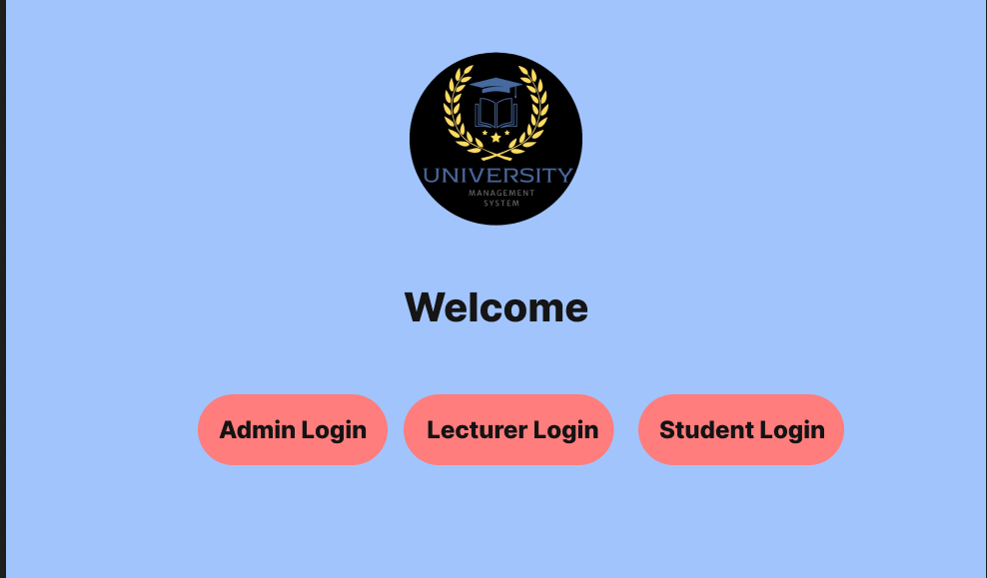 Redirect to home page

In there 3 buttons

Admin Login , Lecturer Login , Student Login

Login Page – username , password

Admin login page only support for usernames which stats with *admin* word –

Username and password is correct redirect to Admin page

Lecturer login page only support for usernames which stats with *lec* word –

Username and password is correct redirect to Lecturer page

Student login page only support for usernames which stats with *st* word –

Username and password is correct redirect to Student page